**LAB REPORT #12** Name: Owais Rao

**I/O and File Streams**  Roll No.:22L-7638

Class: BSEE-1A2

**Introduction:-**

A file must be opened before we can read from it or write to it. To perform file processing in C++, header files **<iostream>** and **<fstream>** must be included in C++ source file. **ifstream** represents the input file stream and is used to read information from files. **ofstream** represents the output file stream and is used to create files and to write information to files. **fstream** represents the file stream generally, and has the capabilities of both ofstream and ifstream which means it can create files, write information to files, and read information from files.

**Objective:-**

* To be able to understand the working of files and functions.

**Procedure:-**

With the help of lab manual, I was able to write codes for given exercises. They are as follows with their outputs:-

**Exercise 1:-**

**INPUT:**

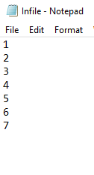

**CODE:**

#include <iostream>

#include <fstream>

#include <cmath>

using namespace std;

void main()

{

ifstream in;

in.open("Infile.txt");

int a;

ofstream out;

out.open("Output_file.txt");

while (!in.eof())

{

in >> a;

out << a << "\t";

out << pow(a, 2) << "\t";

out << pow(a, 3);

out << endl;

}

in.close();

out.close();

}

**OUTPUT:**

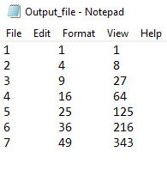

**Exercise 2:-**

**INPUT:**

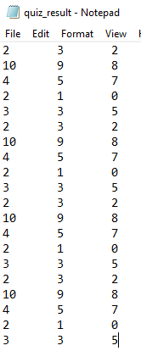

**CODE:**

#include <iostream>

#include <fstream>

#include <cmath>

using namespace std;

void main()

{

ifstream in;

in.open("quiz_result.txt");

int a, b, c;

int sum;

ofstream out;

out.open("totalMARKS_file.txt");

while (!in.eof())

{

in >> a >> b >> c;

sum = a + b + c;

out << sum << endl;

}

in.close();

out.close();

}

**OUTPUT:**

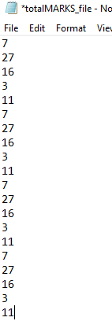

**Exercise 3:-**

**INPUT:**

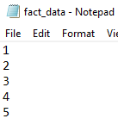

**CODE:**

#include <iostream>

#include <fstream>

#include <cmath>

using namespace std;

void main()

{

ifstream in;

in.open("fact_data.txt");

int a;

double factorial = 1;

ofstream out;

out.open("fact_out.txt");

while (!in.eof())

{

in >> a;

factorial = 1;

while (a > 1)

{

factorial = factorial * a;

a--;

}

out << factorial << endl;

}

in.close();

out.close();

}

**OUTPUT:**

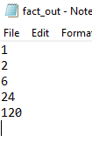

**Exercise 4:-**

**INPUT:**

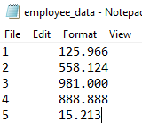

**CODE:**

#include <iostream>

#include <fstream>

using namespace std;

void main()

{

ifstream in;

in.open("employee_data.txt");

int a;

float b, totalSalary, totalTax;

ofstream out;

out.open("employee_annum_data.txt");

while (!in.eof())

{

in >> a >> b;

totalSalary = b * 12;

totalTax = 0.05 * totalSalary;

out << a << "\t" << totalSalary << "\t" << totalTax << endl;

}

in.close();

out.close();

}

**OUTPUT:**

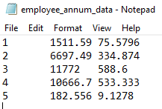

**Issues:-**

No issues were faced.

**Conclusion:-**

* I was able to understand the working of files and functions.

**Applications:-**

* Creating/Opening a file: Using file stream, we create/open a file by specifying new path of the file and mode of operation. Operations can be reading, writing, appending and truncating.
* Writing to a file: Using file stream, we can write into a file.
* Reading from a file: Using file stream, we can read data from a file.
* Special operations in a file: We can do special operations in a file.
* fstream allows us to use the concept of internalization and localization.